Practical no. 09

Aim: Write a program to solve N – queens problem.
Software Requirement: Python IDE, Pycharm, Visual Studio Code, Jupyter Notebook.
Theory: The N-Queens problem is a classic combinatorial problem in which the goal is to place N queens on an N × N chessboard so that no two queens attack each other. This means:
- No two queens share the same row.
- No two queens share the same column.
- No two queens share the same diagonal.
A common approach to solving the problem is backtracking, which explores possible placements for queens and backtracks when a conflict is encountered.
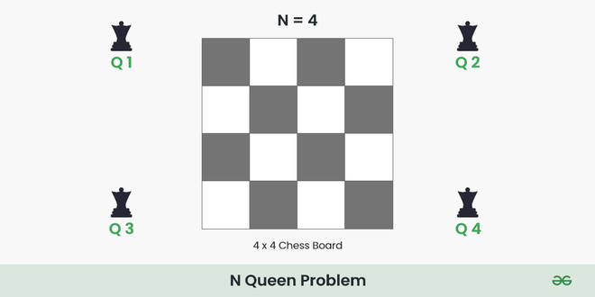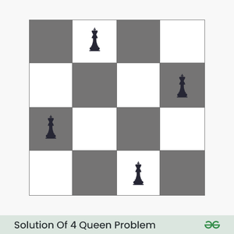

Algorithm Steps:
- Start with an empty board of size N × N.
- Place a queen in the first available column of the first row.
- Move to the next row and attempt to place another queen in a safe column.
- If no safe column exists, backtrack to the previous row and move the queen to the next available safe column.
- Repeat until all queens are placed

Algorithm Analysis:
- Time Complexity: O(N!), as the number of possible configurations grows factorially with N.
- Space Complexity: O(N^2), for storing the board state.

Program:
def is_safe(board, row, col):
for i in range(len(board)):
placed_row = board[i]
placed_col = i + 1
# Check diagonals
if abs(placed_row - row) == abs(placed_col - col):
return False # Not safe
return True # Safe to place
# Recursive utility to solve N-Queens
def solve(col, n, board, solutions, used):
# If all queens placed, add to solutions
if col > n:
solutions.append(board.copy())
return
# Try each row in column
for row in range(1, n + 1):
# If row not used
if not used[row]:
# Check safety
if is_safe(board, row, col):
# Mark row
used[row] = True
# Place queen
board.append(row)
# Recur for next column
solve(col + 1, n, board, solutions, used)
# Backtrack
board.pop()
used[row] = False
# Main N-Queen solver
def n_queen(n):
solutions = []
board = []
used = [False] * (n + 1)
solve(1, n, board, solutions, used)
return solutions
if __name__ == "__main__":
n = int(input("Enter the number of queens: "))
solutions = n_queen(n)
if not solutions:
print("No solution possible")
else:
for solution in solutions:
print(solution)

Example:
Input:
Enter the number of queens: 4
Processing:
- Place the first queen in a valid position in row 1.
- Place the second queen in a non-attacking position in row 2.
- Continue for the remaining rows.
- If a conflict arises, backtrack and try a different column.

Output:
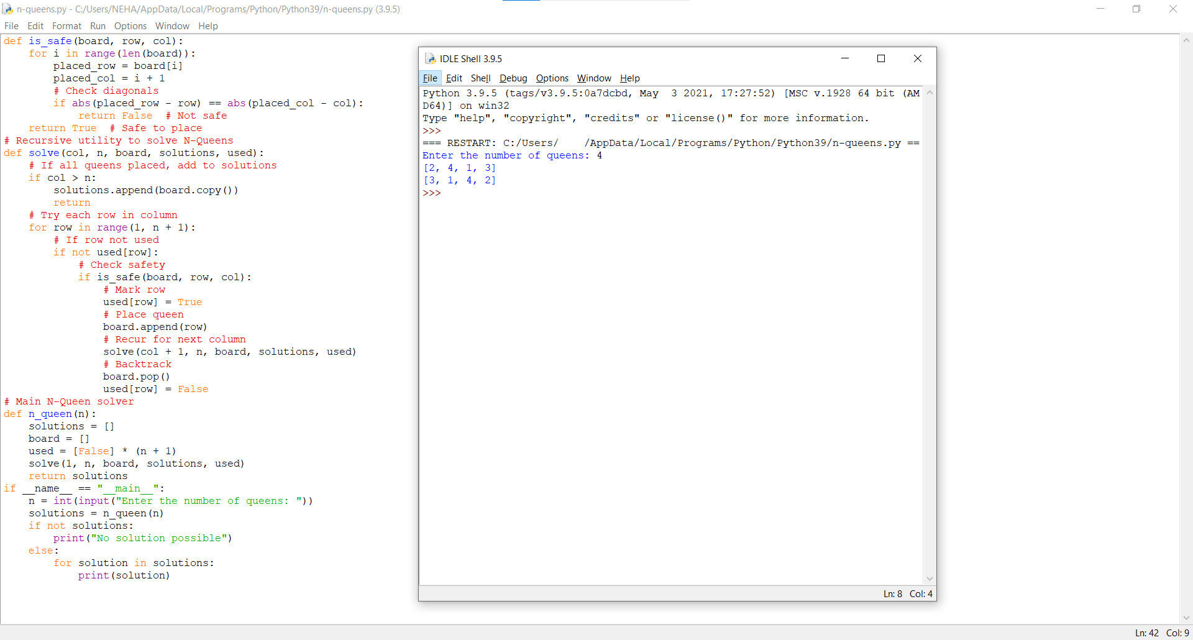
Conclusion:
Hence, I have executed the Python program to solve the N-Queens problem successfully.

